Media Services Event Recording and Post-Production Editing Request Form
updated July 2014

CUSTOMER INFORMATION
Organization or Department:
Contact Name & Box #:
Bill To (Name & Dept/Org):

EVENT DETAILS
IMPORTANT NOTE: all titles and IDs in produced videos will appear EXACTLY as you fill them out below. Please be accurate with spelling and punctuation. (You may also wish to include a program/press release and any custom graphics/logos with this form.)

(Please refer to pages 2 and 3 of this document for detailed guidelines and post-production samples.)
Date of Event:
Full Title of Event:
If applicable, please include:
Title of Series:
Speaker Name(s):
Speaker Title(s)/Identification(s):
Other text for DVD label or menu:

SERVICES REQUESTED |  | APPROX. COST
EVENT AUDIO-RECORDING |  | FREE
EVENT VIDEO-RECORDING |  | $40 base cost

POST-PRODUCTION OPTIONS | QUANTITY
AUDIO CD (specify quantity…) |  | $1.50 each
VIDEO DVD (specify quantity…) |  | $2.00 each
DIRECT DUB-TO-DVD ONLY (no titles, editing or online posting…just a basic archival copy)
WEB STREAMING- PUBLIC (post audio or video online at www.gcc.edu/media) |  | FREE
WEB LINK ONLY- PRIVATE (we’ll host your video and email an unpublished link) |  | FREE
MISC/OTHER SPECIAL REQUESTS:

PLEASE SEND YOUR COMPLETED REQUEST FORM ELECTRONICALLY TO MEDIASERVICES@GCC.EDU, OR BY MAIL TO MEDIA SERVICES (TLC – BOX 3146)

Please keep in mind that 2 & 2 is our general rule of thumb:
REQUEST services at least 2 weeks before your event & ALLOW approx. 2 weeks after your event for video processing…
Media Services Event Recording and Post-Production Guidelines

PERMISSIONS NEEDED FOR ALL RECORDINGS:
All audio and video recordings require advance permission from speakers/presenters, secured in the form of a signed limited license agreement (LLA). Without such explicit written permission, we are unable to rebroadcast/redistribute events. Your completed LLAs may be emailed to mediaservices@gcc.edu, mailed to Media Services (TLC – Box #3146), or handed to the Media Services technician at your event before the recording begins.

AUDIO RECORDINGS AND OPTIONS:
At this time there is no charge for making an audiorecording in our lecture-ready campus venues (Sticht Lecture Hall, Harbison Chapel, Crawford Auditorium, Morledge Room, Pew Recital Hall, Ketler Auditorium, e.g.) when a technician is scheduled to support the event. In other venues which are not pre-equipped with digital audio recording equipment, hourly charges will apply. Audiorecordings can be posted online, produced on audio CD or digitally distributed in a number of convenient ways. The current cost to have CDs duplicated and printed is approximately $1.50 per disc.

VIDEO RECORDINGS AND OPTIONS:
The baseline cost for each campus videorecording is $40. Extended-length, off-campus, and other special shoots will be an additional charge, typically $15/hour after the base rate. Once requested and approved, Media Services will schedule a trained videographer to make an HD recording your event using professional Canon XF-300 video equipment. In the post-production phase, our staff can add titles/IDs/graphics and professionally edit your video before making it available over the web (see Lectures & Events page on www.gcc.edu/media, e.g.) and/or digital media (DVD), based on your service requests in the above form. The current cost to have DVDs duplicated and printed is approximately $2 per disc. (DIY alternative: if you do not need a professional recording but simply wish to capture video for archival use or internal class review, e.g., Media Services offers a cost-savings “do-it-yourself” option with HD camcorders available for checkout so you may easily facilitate your own recordings.)

DUBBING & DUPLICATION:
In addition to duplicating audio CDs and video DVDs from recorded events, we also provide simple dubbing (copying to a newer format), duplication and media printing services at the standard rates (approx. $1.50 per CD and $2 per DVD). There is no charge for dubbing cassette tapes to CD or VHS tapes to DVD when used for academics or college business. For all other dubbing requests, the cost depends upon the length, quantity, and processing time involved; this service is also subject to legal and copyright restrictions. For any duplication and printing services in which you supply a master CD or DVD, just send Media Services the disc along with printing text/label info and it will be added to the project queue.

INVOICING:
Invoices are issued by Media Services to departments and organizations after completion of the final product. In most cases your department will be back-charged electronically by Financial Services for the total amount, typically at the end of the month, and you will receive an electronic receipt for your records. In select cases where electronic funds transfer is not an option, your invoice will request payment (along with any applicable sales taxes) via cash or check, payable to Grove City College. Outstanding cash/check invoices may begin to incur late fees after two weeks of non-payment.

SERVICE GUIDELINES:
These recording and post-production services are intended solely to support the academic and business needs of GCC. They are meant neither for personal nor profitable endeavors outside of this scope. Media Services may not be able to accommodate all requests, especially those made on short notice (less than two weeks from event date.) Service requests are rendered in the order they are received, and may be denied to any individual or group at the discretion of Media Services for any reason. Typical turnaround time for produced videos is approx. two weeks, but can fluctuate significantly depending upon the current volume of video projects. Please allow adequate processing time before inquiring into the status of your final product. Thank you!
Media Services Post-Production Example
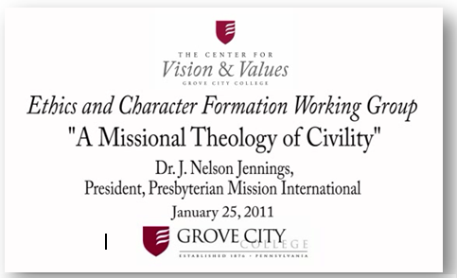
OPENING GRAPHIC ON VIDEO:
Custom logo:
Title of Series:
Full Title of Event:
Speaker Name & ID:

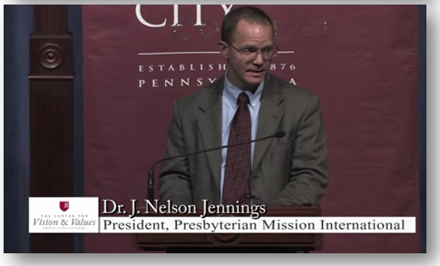

SAMPLE SPEAKER IDENTIFICATION:

Speaker Name & ID:

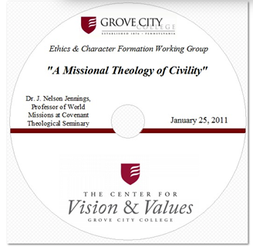
SAMPLE DVD LABEL:

